JSS POLYTECHNIC FOR WOMEN, MYSURU - 06
REPORT ON ACTIVITIES OF DEPARTMENT OF ARCHITECTURE
JANUARY 2022 TO JANUARY2023

- Organising workshop on Emerging Software (JANAUARY 2022)
A workshop was conducted by DA trust, Mysuru, In order to create awareness among Final year students of Architecture on Emerging software used in Construction Industry.
Visual Appreciation and about designersprogramme was organised by DA trust, Mysuru for the Second year students of Architecture.

- Guest Lectures and Site Visit on (FBRAUARY 2022)
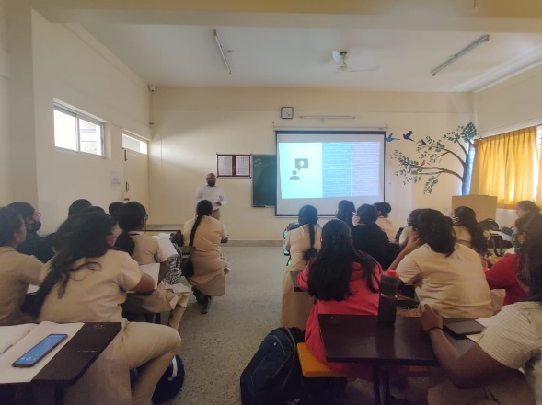
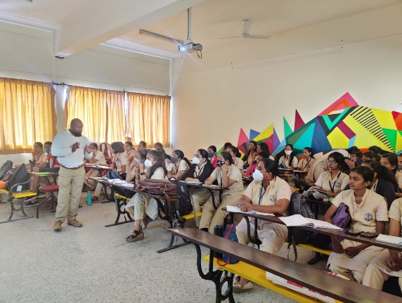
Guest Lecture was organised for the final year students of both Architecture and Interior Decoration on “Entrepreneurship: a lifetime rewards” by Mr. Jacob Swaminathan, MYSURU on 24th February 2022 for the benefit of final year students.
Guest lecture by Mr. Jacob Swaminathan for the final year students.
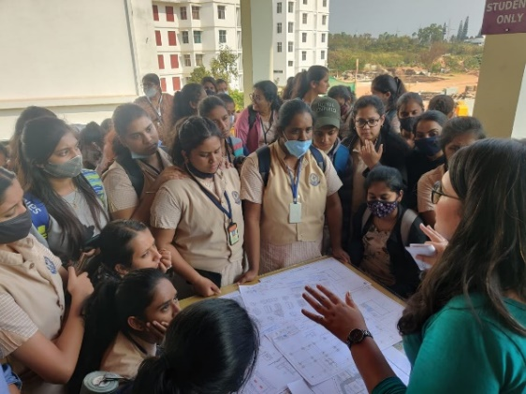
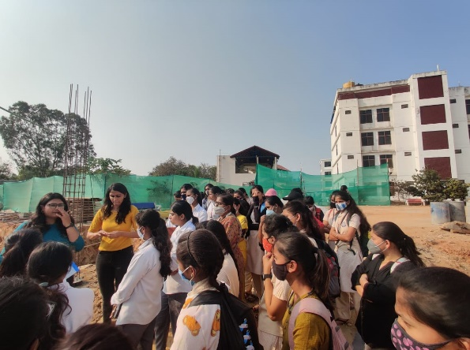

To acquire the knowledge of Building construction, on 25th FEBRAUARY 2022 site visit was organised at GSSS College to study about Constructions details for all the semester students of Architecture and Interior Decoration.
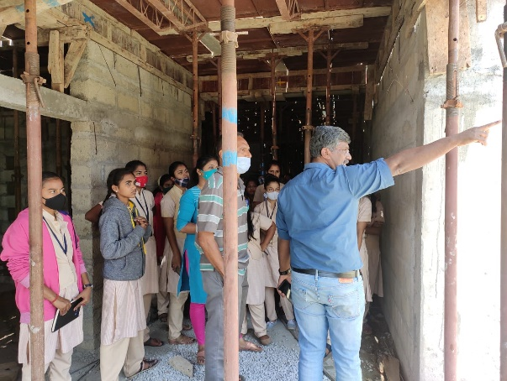
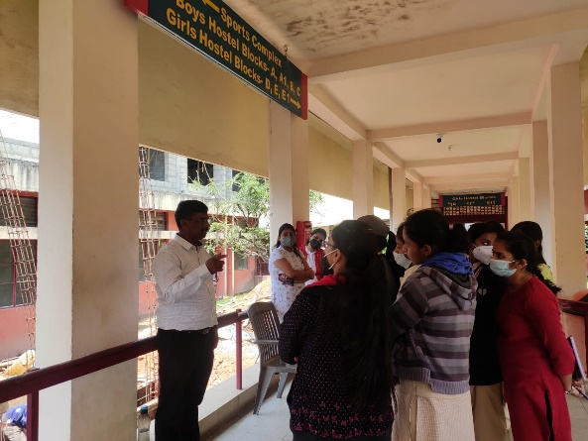

Site visit was organised on 18th FEBRAUARY 2022 at JSSPDA, MYSURU for Second year Architecture and Interior Decoration students to study and acquire practical knowledge about staircase construction details, vertical transportation, centring and shuttering etc.
- Workshop on MODERN SURVEY INSTRUMENTS on 3rd MARCH 2022.

Workshop was conducted on “MODERN SURVEY INSTRUMENTS’’ by Mr.Akshay Kumar S Lecturer, Dept. of Civil Engg, JSS Polytechnic,and MYSURU. On 12th march 2022 for the benefit of second year Architecture students in regarding modern survey instruments.

- Virtual tour on Vernacular and Contemporary Architecture on March.
Virtual tour of Hyder Ali centre, Opera Sydney House, North India places and works of Ar.B V Doshi was conducted by Lalitha rao charitable trust, Desirazu Associates Mysuru. For the benefit of students of the Department of Interior Decoration. To make them aware of Vernacular and Contemporary features of above said buildings.
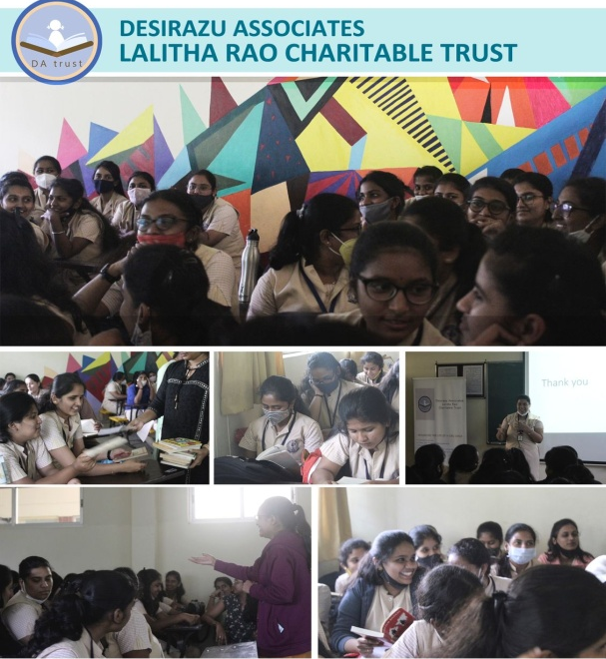
- Virtual tour on Architectural buildings on April.
Virtual tour of Chathrapathi Shivaji Train Terminus, lauri Baker’s Coffee House and Cathedral of Brasilia was organised by Lalitha rao charitable trust, Desirazu Associates Mysuru.For the benefit of students of the Department of Architecture. To learn in detail about low cost materials and alternate construction techniques.
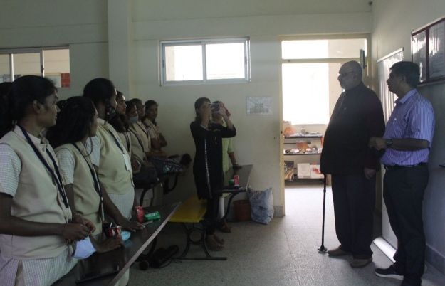

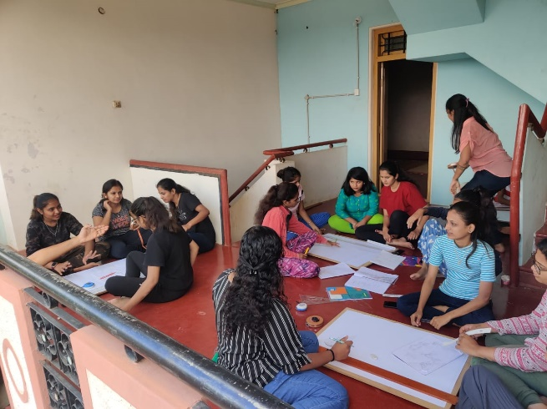
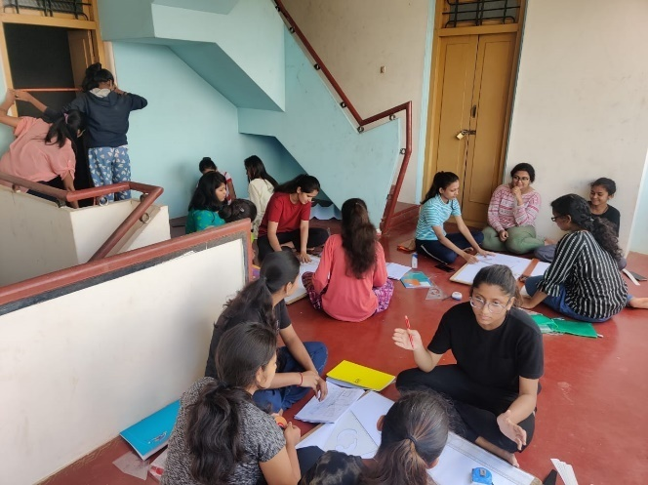
- Conducting measured drawing at Dodda Boohalli, malavalli taluk on 29th MAY 2022
Second year students of Architecture, were taken to Dodda Boohalli, Malavalli, to get practical exposure of conducting measured drawing of an existing building. During the visit students were exposed to truss roof, wooden column, beam, and other such typical features of a courtyard house.

- Curriculum Revision workshop at NITTR, Bengaluru from 6th JUNE to 17th JUNE 2022.
Faculties of Department of Architecture were participated in Curriculum Revision Workshop was held at NITTTR Extension Centre Bengaluru from 6th JUNE to 17th JUNE 2022 for Third year C-20 Syllabus.

- Faculty Development Programme from 21st JUNE to 25thJUNE 2022.

Faculty members of the department are enrolled for the five days Faculty Development programme through online mode, which is being organised by Dept. Of Civil Engg, Rajshree Institute of Management of Technology, Bareilly in collaboration with public works Department (Govt. of Uttar Pradesh) on “Emerging Technologies in Civil Engineering for Construction and Demolition”.

- Alumni visit to the Department
Alumni talk was organised on June 29th 2022 by Ar.Shalini for the First year students of Architecture to inspire and to know more about the course.
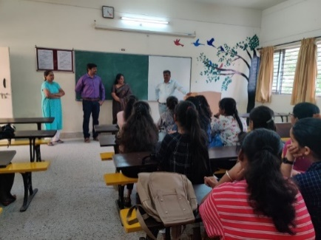
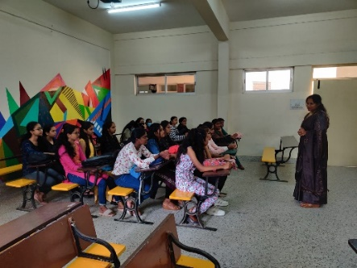

Interaction between Ar.Shalini and First year Students.
- Study Tour to North Karnataka (JULY)
As a part of curriculum, study tour was organised for all the three years of Architecture to North Karnataka, places like Badami, Aihole, Pattadkallu, Kudalasangama, GolGumbaz, to analyse the architectural features of temples which relates to the course.
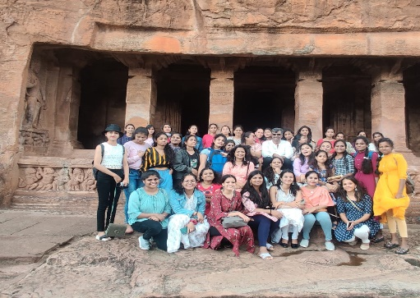

Study tour was organised for all the three years of Architecture to North Karnataka.

- Guest Lecture on “Importance of Interior Design’’
Guest Lecture was organised for the Interior Decoration Department on “Importance of Interior Design’’on 22nd July 2022 by Ms.Shubha Thimmegowda an Interior Designer, Bengaluru., to gain knowledge about the interior aspects.
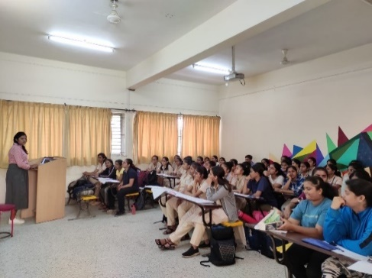
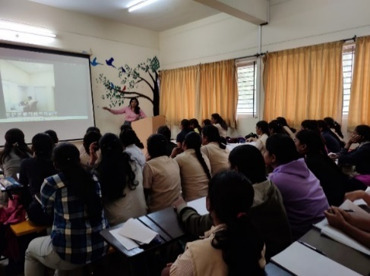

An Interior Designer Ms.Shubha Thimmegowda giving a lecture for the students.

- Azadi Ka Amrit Mahotsav
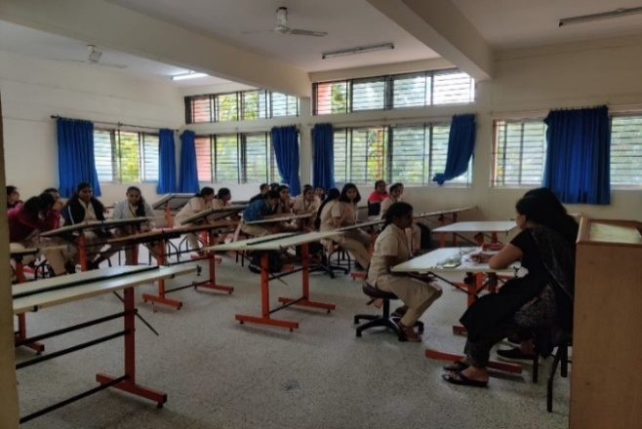
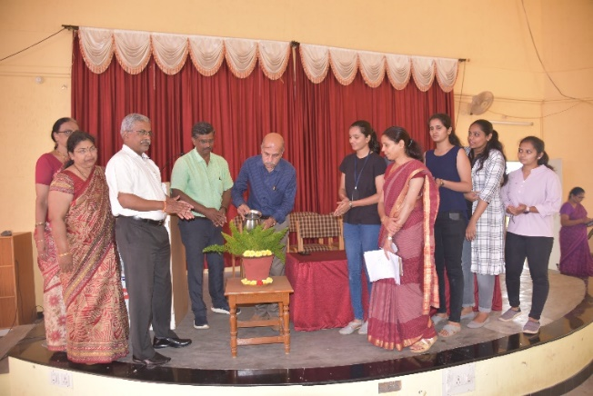
Azadi Ka Amrit Mahotsav is an initiative of the Government of India to celebrate and commemorate 75 years of independence and the glorious history of its people, culture and achievements. The formal function of this auspicious occasion was inaugurated by Principal on 3rd August 2022 and various competitions Painting,Patriotic Song, essay writing, speech,quiz and cultural Skit, were conducted on the same day in our polytechnic. Our students exhibited their talents and won prizes in various Competitions.
Formal Inauguration of the event Essay writing competition
- Workshop on “Building bye laws and zoning regulation”
As a part of curriculum, it was felt essential to understand more about zoning regulation and building byelaws. In this direction a workshop was conducted for the benefit of final year students of Architectureon “Building bye laws and zoning regulation” by Ms.Pankaja M.S on 22-10-2022
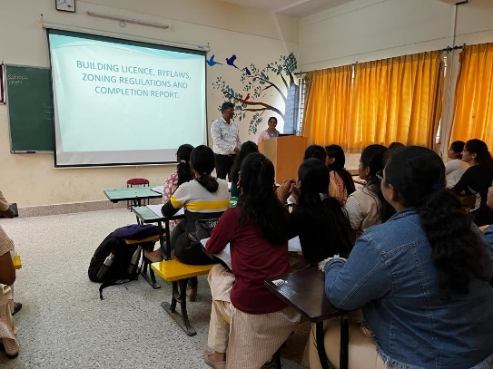
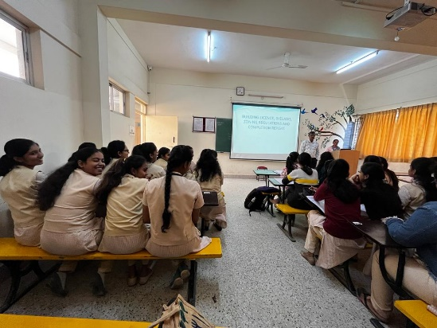

Talk on Building Bylaws and Zoning by Ms.Pankaja for a students.

- Guest Lecture on “Importance of Space Planning and furniture detailing”
Guest Lecture was organised for second and final year students of Architecture on “Importance of Space Planning and furniture detailing” by Ms. Kusuma K.R,Mysuru and also who is an Alumni Of JSSPW on 29-10-2022 for the beneficiary and also know about the floor planning aspects with detailed material specification of furnitures.
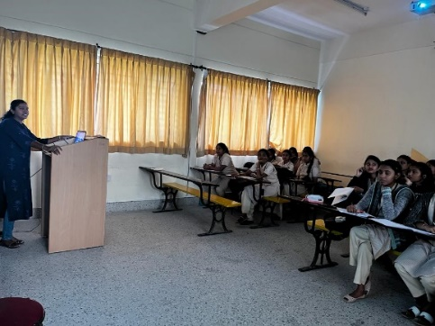
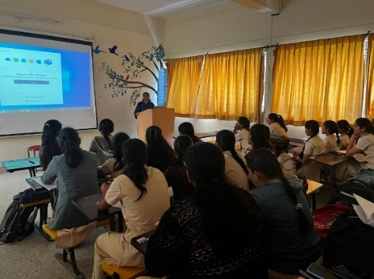

Guest Lecture was organised for second and final year students.

- Site Visits to public building at Chamarajanagar
To know the function and interior aspects of a public building an industrial visit was organised for final year students of Architecture on 5th Nov 2022 to “Chamarajanagar institute of Medical Hospital”. The visit was focused on the study of essential services to be given in the public building like Electrical,A/c ducts,pipelines etc
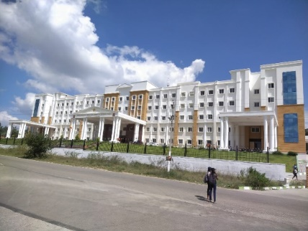
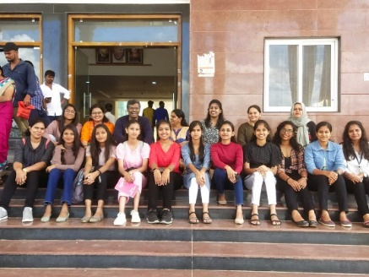

Site Visit at Chamarajanagar institute of Medical Hospital by Final year students.
- Site Visits on “Vishnuvardhan Smarak”
Site visits was organized on 12th Nov 2022 to “Vishnuvardhan Smarak” for the students of Architecture, to study the implementation vernacular architectural feature, use of locally available materials,wall panelling ,sound absorption materials used drama theatre,landscaping elements and also about the construction techniques.
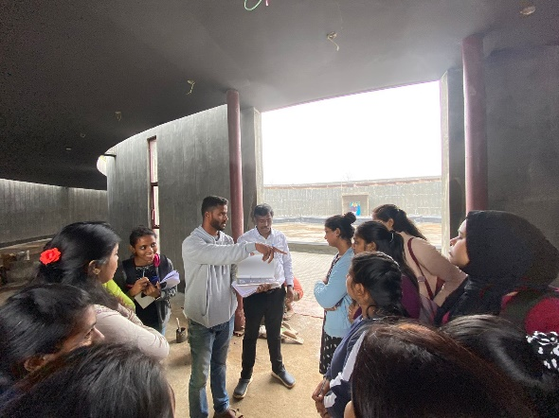
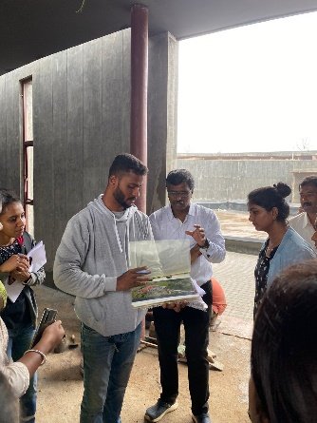

Site Visit to Vishnuvardhan smarak for the students.
- Site Visits on Vijayanagar 4th stage on Commercial Building
Site visits was organised on 19th Nov 2022 Function Hall at Vijayanagar4th stage for the students of Interior Decoration to acquire knowledge of execution works on commercial building construction techniques like False ceiling,wall panelling and other services.
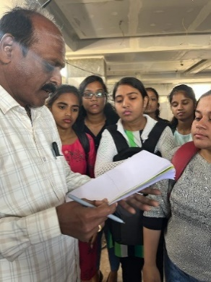
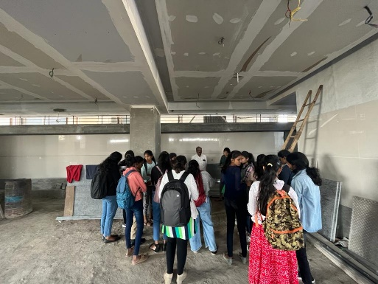

Site Visits to Commercial Building at Vijayanagar 4th stage for the final year students.
- Workshop on “Conceptual Development and working drawing
Workshop was conductedon 26/11/2022 “Conceptual Development and working drawing” by Ar.Nikhila, Principal Architect, Archisage Designeering, and Bengaluru for final year students of architecture. To acquire the knowledge about the process of Conceptual Development in different phases and to do interaction between clients and designers, importance of Working Drawing and electrical services etc.
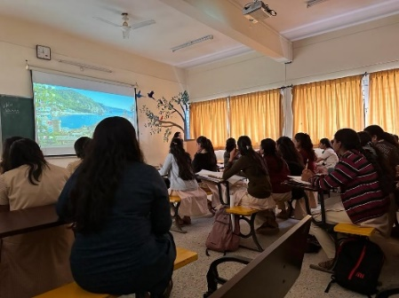
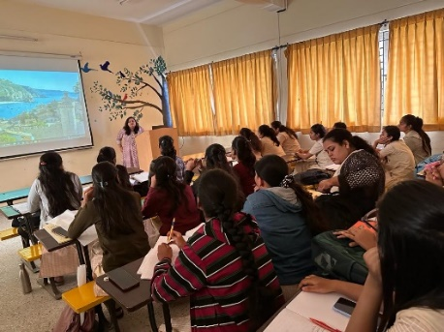

Workshop was conducted for the second and third year students.

- Guest Lecture on “Sustainable Architecture and Interiors”
Guest Lecture was organised on “Sustainable Architecture and Interiors” by Ar.Malini B C, on 3rd Dec 2022 for final year students of Architecture, to gain more knowledge about alternate construction techniques and sustainable architecture.

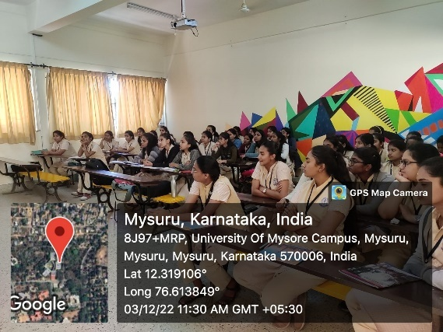
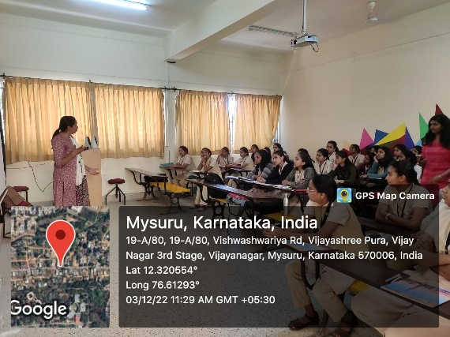

Guest Lecture was organised the second and third year students.

- Guest lecture on “Creating Ambience within Built Space”.
Guest lecture was delivered on the topic “Creating Ambience within Built Space” on 10/12/2022 by Ar.Tejaswini Ramachandra, Practicing Architect, and Mysuru. For the second and final year students of Architecture. To avail knowledge about how to create a healthy environment within a built space.

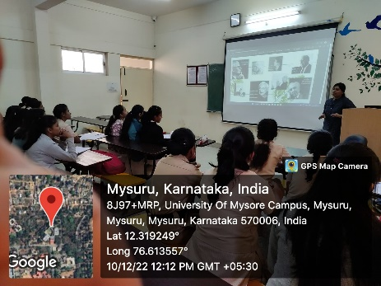
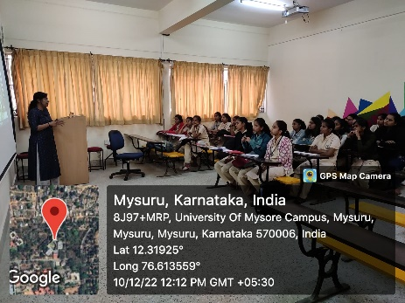

Lecture delivered by Ar.Tejaswini Ramachandran for the students.
- Site Visits for Second year Architecture.
Site visits was organised on 19thDecember 2022 Residance at Vijayashreepura-Working drawing and Brick masonry and Dattagalli- Appartment foundation detail, Mysuru for the students of Architecture to acquire knowledge of execution works on residential building construction techniques.
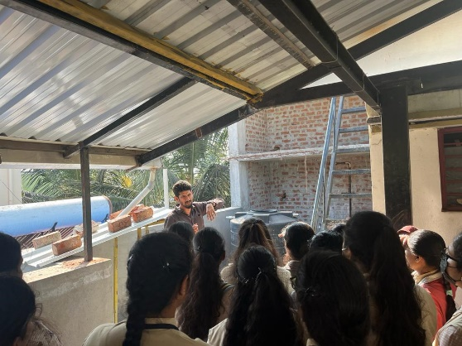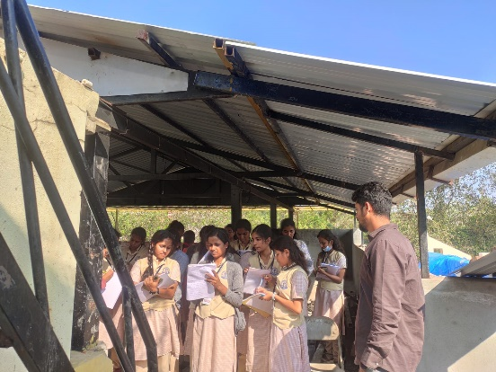
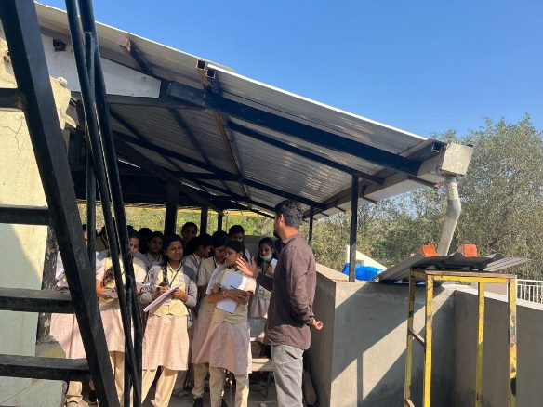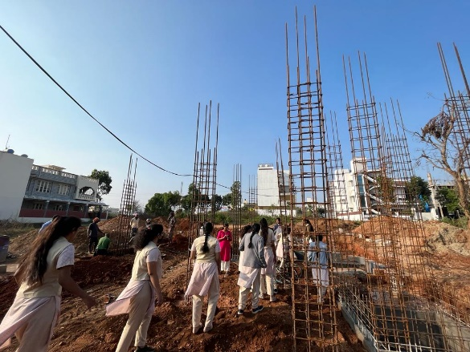

- Organising an “Open Day Exhibition” on 23/12/2022.
An open day which was organised by the college to spread the knowledge of the each course in their respected department , and apparently the principal and the fellow faculties took incharge in each department by helping the students to achieve their works to exhibit on open day. Along with exhibition students were able to organise food stalls, games etc to entertain the public.
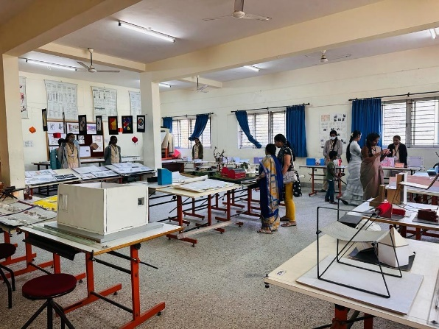

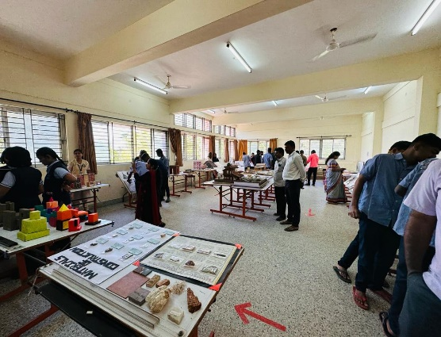

- Preparation of Building Model for Suttur Jathra Exhibition January 2023.
In order to exhibit the model at Sutturu Jaathra Mahotsava 2023, faculty members and students of the department were involved in preparing exterior and interior model of secondary school and drawings of the same.
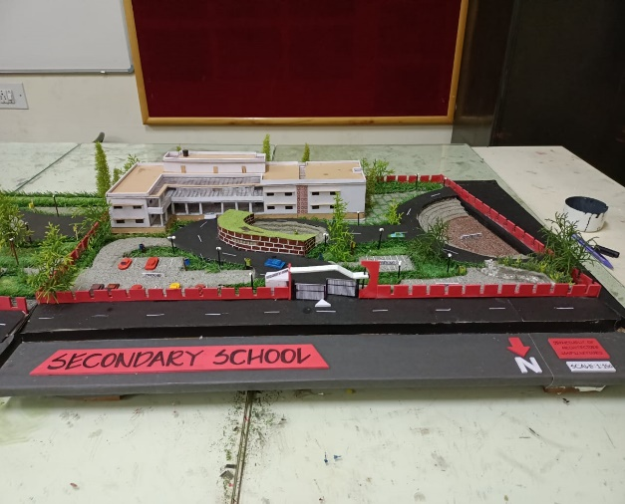
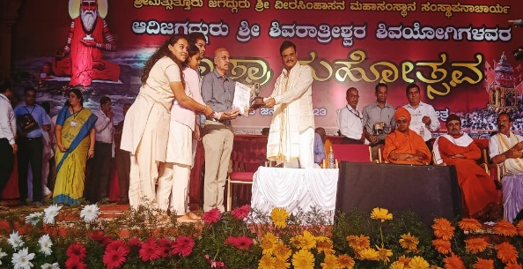
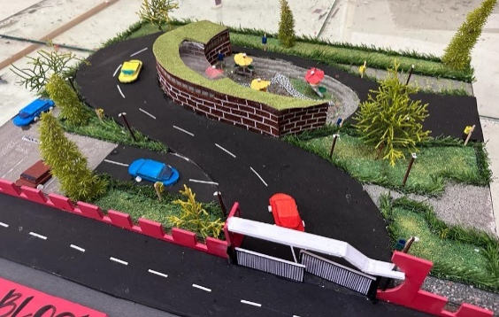

- Workshop on MODERN SURVEY INSTRUMENTS on 13th JANUARY 2023.

Workshop was conducted on “MODERN SURVEY INSTRUMENTS’’ by Mr.Roopesh Kumar P, Lecturer, Dept. of Civil Engg, JSS Polytechnic,Mysuru. On13th January 2023for the benefit of second year Architecture students in regarding modern survey instruments.
